Portraits by Piya Chakrabarti
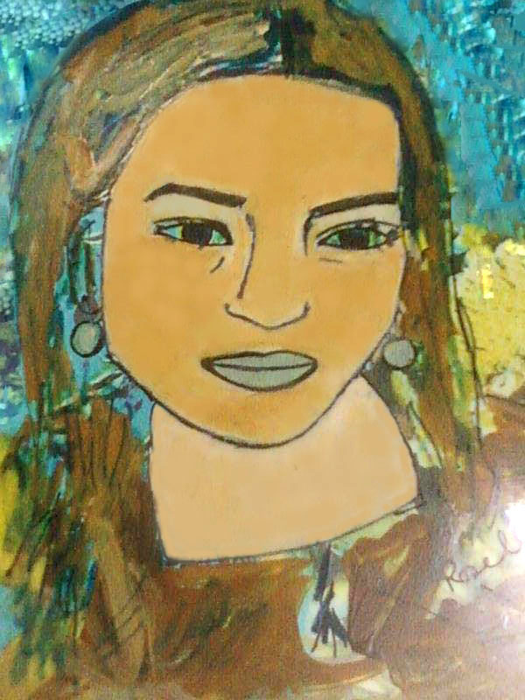  THE NYMPH OF THE BLUE WATERS | The nymph of the blue waters who dwells in the depths of the ocean blues. The lady who is draped in a myriad of colours.  The portrait has been drawn by employing acrylic colours on plastic sheet, a novel technique learnt during an art workshop.

She reminds me of Lucy, the central character of the “Lucy poems” by William Wordsworth.  A portrait of a lady drawn by employing acrylic colours on plastic sheet, a novel technique learnt during an art workshop. | 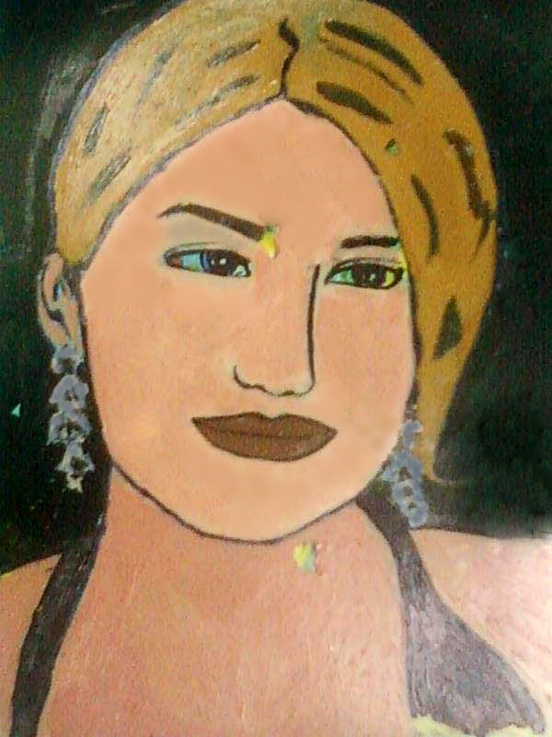  LUCY THROUGH MY EYES

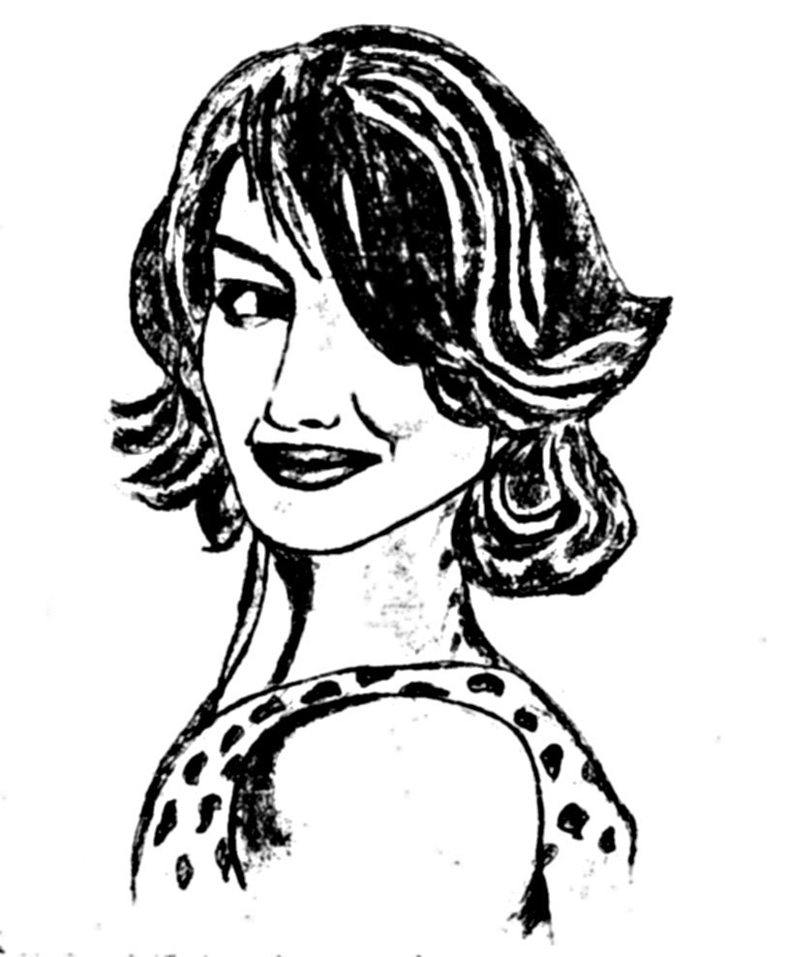  ENCHANTRESS | Depiction of the enchantress with her coquettish glance.  A charcoal painting

THE BLONDE BEAUTY  A pencil sketch | 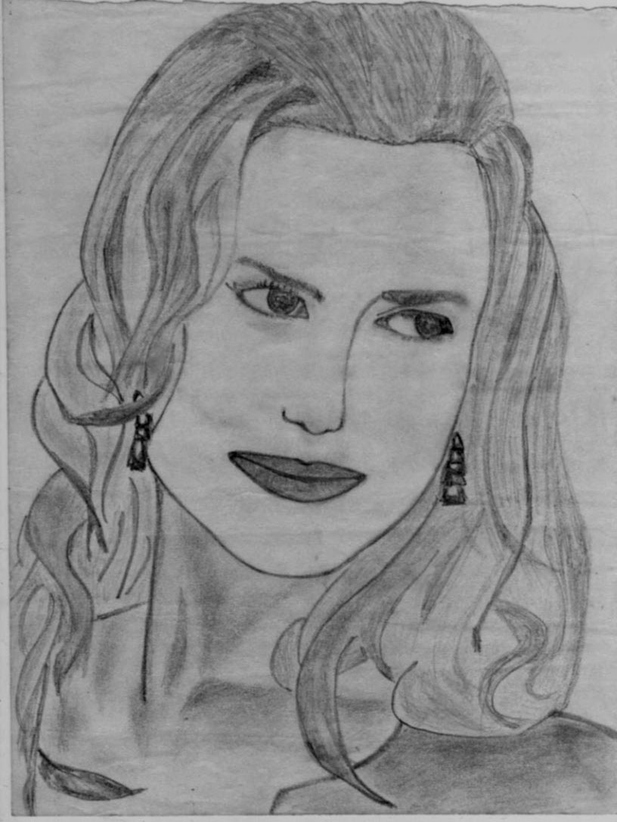

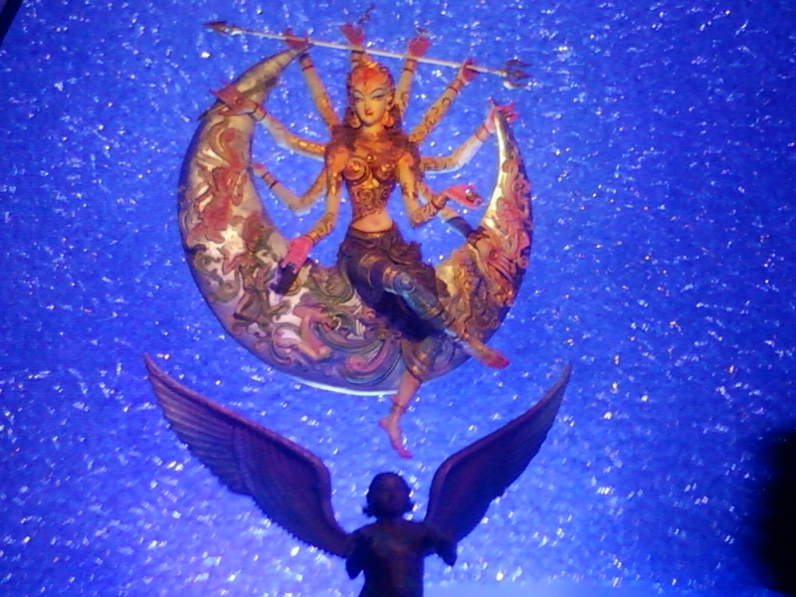  UMA ON THE MOON  A digital photography | Goddess Uma riding the moon, the symbol of Lord Shiva, in a striking pose of elegance and ethereal beauty, while Mahishasura looks above at her with amour in his eyes, before his defeat and death. Lord Kartikeya and Ganesha and goddesses Lakshmi and Saraswati are depicted on the moon.

Piya Chakrabarti is an honors graduate in mathematics from Lady Brabourne College (Calcutta University). She's very much artistically inclined and her passions include classical literature, linguistics, painting, embroidery, gardening, cooking and mathematics. Her persistent dream from childhood is to become an author. Her writings have been published in The Telegraph and in her college magazine and a literary journal. She likes to experiment with her paintings.

Get Your Book Published by
Leaf Press
We publish colorful books on arts, portraits, and paintings. Leaf Press is a self publishing agency bringing out quality books.

Subscribe to
Contemporary Literary Review India
─ The journal that brings articulate writing for articulate readers.
CLRI is published in two editions (1) online quarterly (eISSN 2394-6075) (2) print annually (ISSN 2250-3366).
We welcome authors and readers to register with us online for free. We encourage you to become a paid member with us also. Paid members are waived off any reading fee to the print edition and get one copy of the print edition free of cost whether their piece is included or not.
To become a subscriber, visit: Subscriber to CLRI

